**ABSTRACT**

LifeSkillLuminate presents a pioneering online platform tailored exclusively for individuals with autism, focusing on teaching and practicing essential life skills through engaging animation videos and interactive quizzes. The platform's primary goal is to provide a structured and enjoyable learning experience that fosters independence and confidence in daily living tasks.

The core feature of LifeSkillLuminate is its library of meticulously designed animation videos covering basic life skills such as grocery shopping, money management, cooking, and more.Following each video, users are seamlessly transitioned into a series of interactive 2D quizzes that serve as simulated real-life scenarios.

These quizzes offer users the opportunity to apply the concepts learned in the videos through hands-on practice. By presenting challenges like selecting items at a virtual grocery store or counting money for a purchase, users can reinforce their understanding and build proficiency in essential life skills. Each quiz is designed to be fun and engaging, providing immediate feedback to enhance learning outcomes.

While LifeSkillLuminate currently focuses solely on teaching and practicing modules without community features or progress tracking, its streamlined approach ensures a laser focus on skill acquisition. By combining captivating animation videos with interactive quizzes, the platform delivers a highly effective learning experience that promotes independence and self-sufficiency in individuals with autism.

LifeSkillLuminate represents a significant step forward in leveraging technology to support the unique learning needs of individuals with autism, providing a valuable resource for enhancing essential life skills in a user-friendly and accessible format.

**ACKNOWLEDGEMENT**

**TABLE OF CONTENTS**

**CHAPTER NO. TITLE PAGE NO.**

**ABSTRACT iii**

**LIST OF FIGURES vi**

**LIST OF ABBREVIATIONS vii**

**1. INTRODUCTION 1**

1.1 INTRODUCTION 1

1.2 OBJECTIVE 3

1.3 EXISTING SYSTEM 3

1.4 PROPOSED SYSTEM 4

**2. LITERATURE REVIEW 5**

**3. SYSTEM DESIGN 10**

3.1.1 USE CASE DIAGRAM 10

3.1.2 ARCHITECTURE DIAGRAM 11

3.1.3 SEQUENCE DIAGRAM 12

**4. PROJECT DESCRIPTION 13**

4.1 MODULES 13

**5. OUTPUT SCREENSHOTS 15**

**6.** **CONCLUSION** **18**

**APPENDICES 19**

**REFERENCES 30**

## LIST OF FIGURES

## LIST OF ABBREVIATIONS

**CHAPTER 1**

**INTRODUCTION**

* 1. **Introduction**

In a world where independence is often synonymous with success and fulfillment, individuals with autism face unique challenges in achieving autonomy in their daily lives. Simple tasks that many take for granted, such as grocery shopping, managing finances, or cooking a meal, can present significant hurdles for individuals on the autism spectrum. These challenges can not only hinder their ability to lead independent lives but also impact their sense of self-worth and inclusion within society.

Recognizing the critical importance of addressing these barriers to independence, our project, “LifeSkillLuminate”, is dedicated to empowering autistic individuals by providing them with the tools and resources they need to navigate everyday life with confidence and competence. Through a combination of engaging animation videos and interactive quizzes, LifeSkillLuminate offers a structured and supportive learning environment tailored specifically to the needs of individuals with autism.

At the heart of our project lies a deep understanding of the unique learning styles and sensory sensitivities of individuals on the autism spectrum. We recognize that traditional methods of instruction may not always be effective for this population, which is why we have developed a series of captivating animation videos that are visually stimulating and easy to understand. These videos cover a range of essential life skills, breaking down complex tasks into manageable steps and providing clear, step-by-step guidance.

But our commitment to empowering autistic individuals goes beyond just teaching basic life skills. We understand that true independence requires not only the acquisition of practical skills but also the confidence to apply them in real-world situations. That's why our platform includes interactive quizzes that simulate everyday scenarios, allowing users to practice and reinforce their skills in a safe and controlled environment. By providing immediate feedback and opportunities for hands-on learning, these quizzes help build confidence and competence, paving the way for greater independence and autonomy.

Through LifeSkillLuminate, we aim to bridge the gap between the aspirations of individuals with autism and the everyday realities they face. By equipping them with the skills and confidence they need to tackle life's challenges head-on, we believe that we can help break down barriers and empower autistic individuals to live life to the fullest, just like anyone else. Ultimately, our goal is not just to teach life skills, but to foster a sense of empowerment and inclusion, ensuring that every individual, regardless of their abilities, has the opportunity to thrive and succeed.

* 1. **Objective**

The primary objective of our project, LifeSkillLuminate, is to create a comprehensive and user-friendly platform that supports the unique learning needs of individuals with autism, ultimately empowering them to lead independent, fulfilling, and meaningful lives. We aim to address the unique challenges faced by individuals on the autism spectrum in navigating everyday tasks that are often taken for granted by neurotypical individuals.

Specifically, our objectives include:

1.**Facilitating Skill Acquisition**: We seek to facilitate the acquisition of practical life skills such as grocery shopping, cooking, managing finances, and using public transportation through engaging animation videos and interactive quizzes. By breaking down complex tasks into manageable steps and providing clear, step-by-step guidance, we aim to make these skills more accessible and attainable for individuals with autism.

2. **Fostering Confidence and Competence**: We aim to foster confidence and competence in individuals with autism by providing opportunities for hands-on learning and practice in a safe and supportive environment. Through interactive quizzes that simulate real-life scenarios, users can apply the skills they've learned and receive immediate feedback, helping to build confidence and reinforce learning outcomes.

3**. Promoting Independence and Autonomy**: Our ultimate goal is to promote independence and autonomy among autistic individuals, enabling them to lead fulfilling and self-directed lives. By equipping them with the skills and confidence they need to navigate everyday tasks independently, we aim to reduce reliance on external support systems and empower individuals to live life on their own terms.

4**. Enhancing Quality of Life**: We seek to enhance the overall quality of life for individuals with autism by improving their ability to engage with and participate in everyday activities. By addressing barriers to independence and promoting skill development, we aim to empower individuals to overcome challenges and maximize their potential for personal growth and fulfillment.

5. **Promoting Inclusion and Empowerment**: Through our project, we aim to promote greater inclusion and empowerment for individuals with autism within society. By providing access to tailored learning resources and fostering a sense of competence and self-efficacy, we seek to challenge stereotypes and promote acceptance of neurodiversity, ensuring that individuals with autism are valued and respected members of their communities.

* 1. **Existing System**

In considering the existing system within the domain of teaching life skills to individuals with autism, it's important to recognize the diverse range of approaches and resources available, as well as the specific challenges and limitations that may exist. Here's an overview of the existing system and some of its key components:

1. **Traditional Instruction Methods**: Historically, life skills instruction for individuals with autism has often relied on traditional teaching methods, such as one-on-one instruction, group sessions, or written materials. While these approaches may be effective for some learners, they may not always be accessible or engaging for individuals with autism, who may have unique learning styles and sensory sensitivities.

2. **Therapeutic Interventions**: Many individuals with autism receive support and instruction through various therapeutic interventions, such as occupational therapy, speech therapy, and applied behavior analysis (ABA). These interventions may include targeted skill-building activities and strategies to address specific challenges related to daily living skills.

3. **Printed and Digital Resources**: There is a wide range of printed and digital resources available for teaching life skills to individuals with autism, including books, worksheets, and online platforms. These resources may cover topics such as personal hygiene, household chores, money management, and social skills, providing guidance and support for both individuals and caregivers.

4. **Specialized Programs and Centers**: Some communities offer specialized programs and centers specifically designed to support individuals with autism in developing life skills. These programs may include structured activities, socialization opportunities, and vocational training to help individuals build independence and prepare for adulthood.

5. **Community Support Services**: In addition to formal instruction and programming, individuals with autism may access community support services, such as vocational rehabilitation, supported employment, and independent living assistance. These services aim to provide ongoing support and resources to help individuals achieve greater independence and integration into society.

While these existing systems and resources play a valuable role in supporting individuals with autism in developing life skills, there are often gaps and limitations that need to be addressed. These may include limited accessibility, lack of individualization, and insufficient opportunities for practice and generalization of skills in real-world settings.

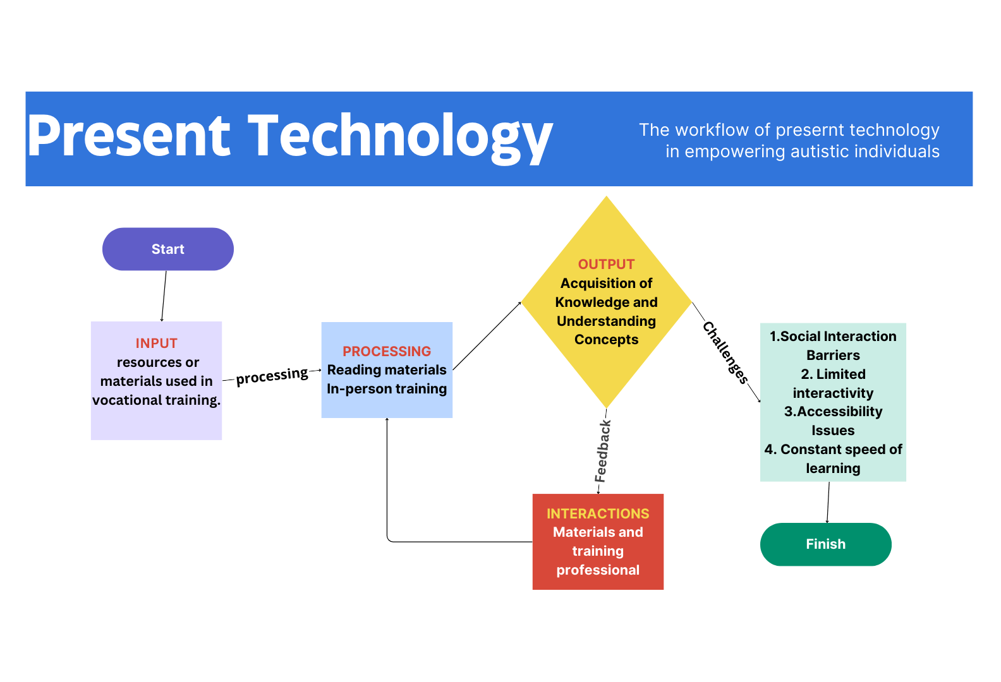

Fig 1.3.1

* 1. **Proposed System**

LifeSkillLuminate, seeks to complement and enhance the existing system by providing a user-friendly, interactive, and customizable platform specifically tailored to the needs of individuals with autism. By leveraging technology and simulation-based learning, we aim to fill gaps in traditional instruction methods and provide individuals with autism with the tools and resources they need to develop essential life skills and achieve greater independence and autonomy.

Our proposed system, LifeSkillLuminate, represents an innovative approach to teaching essential life skills to individuals with autism through a user-friendly online platform. Leveraging cutting-edge technology and evidence-based practices, LifeSkillLuminate aims to address the unique learning needs of individuals with autism by providing engaging and interactive learning experiences tailored to their specific abilities and preferences.

Key Components of the Proposed System:

1. **Animation Videos**: LifeSkillLuminate will feature a library of captivating animation videos covering a range of essential life skills, including grocery shopping, cooking, managing finances, using public transportation, and personal hygiene. These videos will be designed to be visually appealing, easy to understand, and accessible to individuals with autism, incorporating clear visuals, simple language, and step-by-step instructions.

2. **Interactive Quizzes**: Following each animation video, users will have the opportunity to engage in interactive quizzes that simulate real-life scenarios related to the skills they have just learned. These quizzes will be designed to be fun and engaging, allowing users to practice and reinforce their skills in a safe and supportive environment. Immediate feedback will be provided to help users improve.

3.**Technology Stack:**LifeSkillLuminate will be built using modern web technologies, making it accessible across a range of devices, including desktop computers, laptops, tablets, and smartphones. The platform will utilize responsive design principles to ensure a seamless and consistent user experience across different screen sizes and devices.

Overall, our proposed system, LifeSkillLuminate, represents a groundbreaking approach to teaching essential life skills to individuals with autism, leveraging technology and innovation to create a supportive and empowering learning environment. By providing engaging animation videos, interactive quizzes, and customizable learning experiences, LifeSkillLuminate aims to empower individuals with autism to develop the skills and confidence they need to lead independent and fulfilling lives.

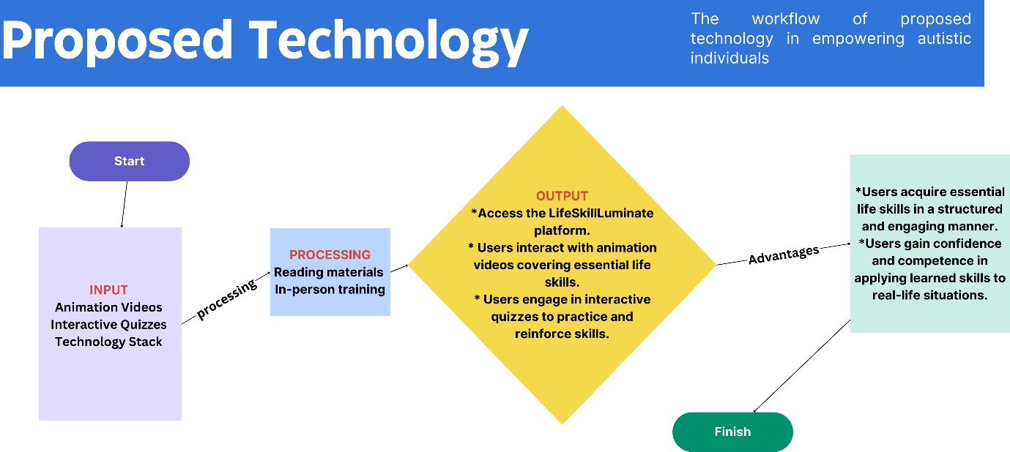

Fig 1.3.2

**CHAPTER 2**

**LITERATURE REVIEW**

**CHAPTER 3**

**SYSTEM DESIGN**

**3.1 USE CASE DIAGRAM**

Use cases capture the main functionalities and interactions of LifeSkillLuminate, Fig 3.1 provides a comprehensive overview of how users engage with the system to learn essential life skills. It illustrates the various interactions and relationships between users and the system.

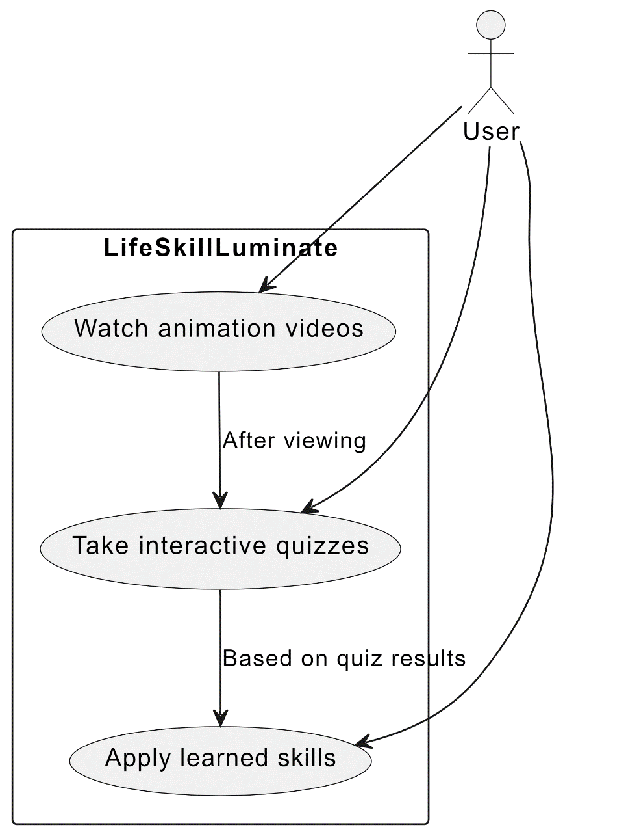

**3.2 ARCHITECTURE DIAGRAM**

The components shown in Fig.3.2 collectively form the user interface, quiz, and video functionalities of LifeSkillLuminate, providing users with an engaging and accessible platform for learning essential life skills. The architecture diagram for LifeSkillLuminate illustrates the high-level structure and components of the platform's system design Each component plays a distinct role in delivering the platform's functionalities. Through this visual representation, the architecture diagram provides a comprehensive overview of the system's design principles, scalability, and extensibility, facilitating effective communication and collaboration among development teams.

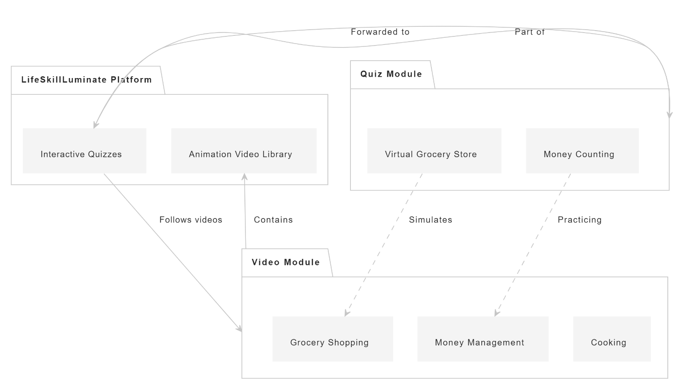

Fig 3.2

**3.3 SEQUENCE DIAGRAM**

The sequence diagram for LifeSkillLuminate, Fig 3,3, illustrates the interactions between users and the system as they navigate through the platform's features. It outlines the sequential flow of events, starting from user interactions with the user interface components to the backend processing of requests and responses. Each step in the sequence represents a specific action or operation performed by the user or the system, showcasing the dynamic exchange of information and functionality within the platform. Through this visual representation, the sequence diagram provides insights into the order of operations and the dependencies between different components, helping to ensure a smooth and intuitive user experience.

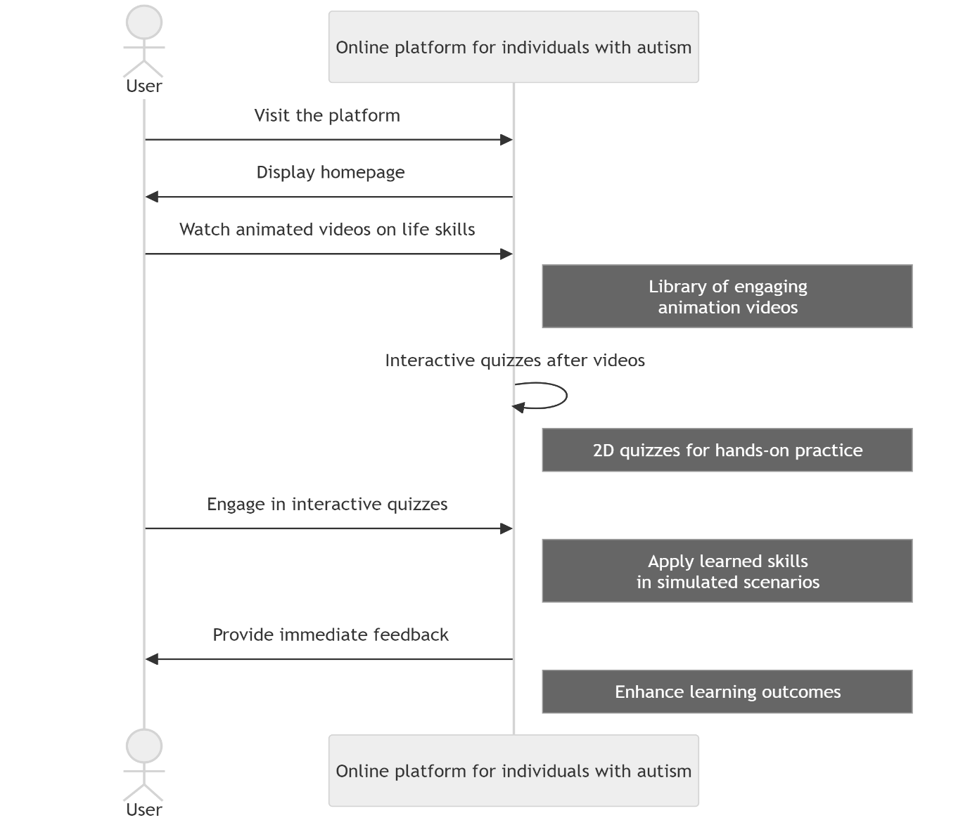

Fig 3.3

**CHAPTER 4**

**PROJECT DESCRIPTION**

**4.1**